Sunscreens
You don't need a prescription for this item - it can be purchased at low cost from shops and pharmacies. NHS England would appreciate your support in helping to save money by buying these if you are able to, rather than having it on prescription. The cost of sun protection products in Kent and Medway was £10,500 in 2023/24
Sunscreens protect skin against ultraviolet (UV) radiation. This is divided into ultraviolet A (UVA) and ultraviolet B (UVB).

Availability of sunscreens on prescriptions
Only certain sunscreens can be prescribed on the NHS by a doctor, and they can only be prescribed for certain approved indications. For example, sun blocks can be prescribed for use by people with conditions such as photodermatoses, a group of skin conditions associated with an abnormal reaction to UV radiation. UVA radiation is largely responsible for photodermatoses whereas UVB is the main factor in sunburn.

Sunscreens
Sunscreens in the UK are usually labelled with a sun protection factor (SPF).
The SPF shows the level of protection against UVB, not the protection against UVA.
The level of UVB protection offered by a sunscreen is rated on a SPF scale of 2-50+.
SPF between 2 to 14 offer the least protection and ratings of 50+ offer the strongest forms of UVB protection.
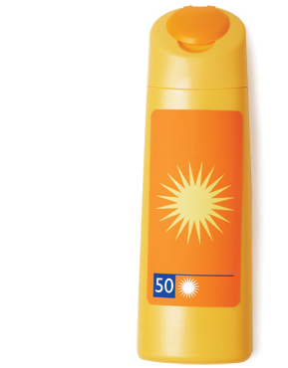

SPF level showing the level of UVB protection

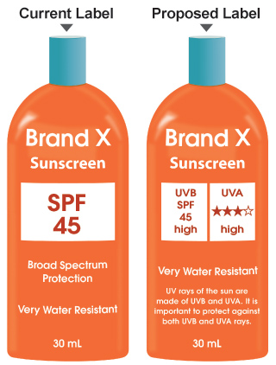
No standard method exists to measure the UVA protection of sunscreens but the star system is generally accepted. The stars scale ranges from 0 to 5, with 5 providing the highest protection and 0 the lowest protection. The stars indicate the percentage of

UVA radiation absorbed by the sunscreen in comparison to UVB.
A sunscreen with an SPF of 30 or more and a UVA rating of 4 or 5 stars is generally considered a good standard of sun protection.
New recommendations on labelling of sunscreens means that as well as the SPF number, the SPFs are categorised as providing low to very high protection, to make the SPF guide easier to understand. The table below illustrates this.
New label | SPF
Low protection | 6 to 14 (i.e. SPF 6 and 10)
Medium protection | 15 to 29 (i.e. SPF 15, 20 and 25)
High protection | 30 to 50(i.e. SPF 30 and 50)
Very high protection | 50 + (i.e. SPF 50+)

Advice for patients
- If you are not eligible for sunscreens on prescription under the approved indications on the NHS then you can purchase an appropriate sunscreen over the counter (OTC) in a pharmacy or supermarket.
- Make sure the sunscreen you buy has at least SPF 15 to protect against UVB and good UVA protection, for example, at least '4-star UVA protection’.
- Sunscreens are not a substitute for covering the skin and avoiding sunlight.
- Ensure that you follow the manufacturer’s instructions about applying the sunscreen and the amount to use. Apply the sunscreen 15 to 30 minutes before going out in the sun to allow it to dry, and then again shortly after heading outdoors to cover any missed patches and to make sure you’re wearing a sufficient layer. Be extra careful to apply sunscreen to ears, the temple, the back, and sides of the neck.
- Reapply the sunscreen at least every two hours.
- ‘Water resistance’ is tested by the ability of a sunscreen to retain its sun protection properties following two 20-minute intervals (40 minutes total) of moderate activity in water. However, up to 85% of a product can be removed by towel drying, so you should reapply after swimming, sweating, or any other vigorous or abrasive activity.
- Protect the skin with clothing, including a hat, t-shirt, and sunglasses.
- Spend time in the shade between 11am and 3pm when it’s sunny.
- Keep babies and young children out of direct sunlight.
- If you are avoiding the sun completely you may need to take a vitamin D supplement to reduce the risk of vitamin D deficiency. Supplements are widely available from pharmacies, supermarkets, or health food shops.

Further information
Further information on sun safety for patients is available from:
British Association for Dermatologists Sunscreen Fact Sheet http://www.bad.org.uk/for-the-public
NHS Choices http://www.nhs.uk/pages/home.aspx

